MISS JIM BOWIE DAYS 2021

Welcome to the 2021 Miss Jim Bowie Days Pageant!! We are excited to have you as a contestant. On the following pages you will find.

Contest Rules
Application
Check list of information due June 4th to the Shopper in Bowie or sent via email
Liability waivers
Schedule
Horsemanship pattern

If you have any questions, please contact:

Shalee Rater: (254)-979-5780
shaleerater@gmail.com

Queen and Little Miss Official Rules
The Jim Bowie Days Rodeo Committee forms this contest to provide opportunities for young women to represent this GREAT town and our rodeo heritage. As well as promoting the sport of rodeo.
The winners of this contest are young women who strive to promote the sport of rodeo in everyday life. She is talented, personable, and a horsewoman with a vast knowledge of the sport of rodeo, equine industry and the Bowie area. She is a woman who loves to travel to various areas of the state representing Jim Bowie Days Association and the City of Bowie.
Eligibility
Miss Jim Bowie Days contestants must be between the ages of 14-21 as of June 1, 2021.
Little Miss Jim Bowie Days contestants must be younger than 13 as of June 1, 2021.
All contestants will be required to attend a virtual contestant meeting that will be held on June 1st at 7:00 pm. (Unless approved by the queen committee)
General Rules
- Contestant must provide a copy of her birth certificate.
- Miss and Little Miss contestants must pay the required application fee of $25.00 with a name of a sponsorship by June 4th.
- All required documents must be presented to the committee via the Shopper or sent via email to Shalee by June 4th.
- No contestants may be married, pregnant, or have a child. Contestants cannot become married or pregnant during her year of reign.
- Contestants cannot currently be holding another title, also cannot run for another title during her reign unless that competition is to be Miss Rodeo Texas. (Subject to committee discretion)
- Any grievances must be in writing and submitted to the pageant director and the rodeo committee. Entry fees are non-refundable.
- Contestant will go in a drawn order for the entire pageant. Your sash will have your sponsors’ name on it. These will be provided to you at Thursday night’s rodeo. You will wear this sash the entire pageant except during horsemanship and the brunch.
- Contestant must wear RODEO QUEEN ATTIRE. (ABSOLUTLY NO BLUE JEANS)
- If a contestant or an awarded queen should conduct herself in an inappropriate manner a meeting with Rodeo Committee will be held and the proper measures will be taken.
- ALL contestants will be required to sell at least 50 general admission tickets to the rodeo. Value of tickets are $8.00. Any tickets sold over the required 50 will qualify the contestant for points on the ticket sale category of the score sheet. Only top 3 ticket sellers will receive points. (Example top tickets seller will receive 10pts., 2nd. will receive 6pts., 3rd. will receive 2pts.)

Queen and Little Miss application form:

First Name:________________________________Last Name:_______________________________

Address:__________________________________City:____________________State:___________

Phone #:__________________________________Email address:____________________________

Age: _______________DOB:____/_____/_____

School Attending:___________________________Year in school (going into):_________________

Parents Names:_____________________________________________________________________

Name of Sponsor you will be representing:_______________________________________________

Release of Liability

I, the undersigned, being a non-paid contestant, applicant and participating in the Queen and Little Miss contest of the Jim Bowie Days Rodeo Committee, and recognizing the said sponsor is a non-profit organization; and recognizing the non-profit nature of the pageant, and as express consideration for being allowed to enter the contest. I hereby release said Jim Bowie Days Rodeo Committee from any and all claims or demands for liability for accidents or any other liabilities and makes said agreement for herself, her heirs and executors and states that she is of lawful age and legally entitled to make the complete release. All contestants’ signatures must be accompanied by a parent.

Contestant Signature: _______________________________________________
Parent Signature: ___________________________________________________
Date:____________________________________________________________

Jim Bowie Days Contestant Checklist

Please turn in the following with the completed application form to the Shopper or send it to Shalee via email by June 4th.

_____Completed application.
_____Copy of birth certificate.
_____A vertical 4x6 headshot color photo; please wear a western hat for this photo. This
photo will be provided to the local advertising companies.
_____$25.00 sponsorship fee.
_____Liability waiver.

As a committee, we do realize there may be unforeseen reasons that you cannot attend the meeting on June 1st. If so, we ask that you contact Shalee to discuss drop off or mailing of the above credentials to:

Jim Bowie Days Association
PO Box 54
Bowie, Texas 76230
Attention Carol Head.

If you are unable to attend, it would be a great idea to send a representative…At this time, you will be given instructions on how to get your tickets to sell.

TENTATIVE JBD ROYALTY SCHEDULE

Thursday June 24, 2021
6:45 pm – Pageant contestants will check behind the bucking chutes with the pageant directors. At this time, you will receive your sashes.
7:00 pm - You will need to be on horseback and ready to ride in the Grand Entry that starts at 7:30pm. As soon as you ride in the Grand Entry you will be staged to enter the arena again and be introduced during the presentation of the colors.
During every performance, the contestants will be asked to assist with the sheep during mutton bustin’ and to ride out in the back of the pickup that delivers the barrels for the barrel racing event. Also, you will be assisting children in the arena during the nightly calf scramble.

Friday June 25, 2021
8:00 am –SHARP with horses warmed up and ready to start the horsemanship competition. The reigning Queen will set the pattern, followed by the queen contestants. Then, the reigning Little Miss will set the reigning pattern follow by the Little Miss contestants’ pattern. After each contestant does their pattern, they will stay mounted and be directed to walk to the judge’s staging area. Little Miss contestants will not be required to dismount.
10:00am – Brunch will be served for the contestants and parents in the Bowie Community Center. After eating, the contestants will be directed to the judge’s staging area for the judges to ask personality and rodeo questions. NO PARENTS OR COACHES are allowed in this area.
2:15 pm – All contestants will attend the Pioneer Reunion Royalty and Crowning which will be held at the Bowie Community Center, hall to be designated. This is not a judged event; it is just a community service. You will be asked to introduce yourself and give and brief statement about yourself. The ladies that put this on love to see the queen contestant and learn more about them.
7:00 pm – Repeat of Thursday night.
Saturday June 26, 2021
10:00 am – Park at the corner of Pecan & Lindsey Street downtown Bowie to ride in parade. It starts at 10:30 am.
ASAP after the parade, please return to the rodeo grounds to help with the hamburger feed which is held in the west hall of the Bowie Community Center. The contestants will be serving. You will be allowed to eat after everyone has been served at no charge. After this event, the contestants will go directly to the 2nd Monday Pavilion to assist with the Pet Parade and then to the Pool Pavilion to assist with the frog jumping and turtle race.
7:00 pm- Repeat of Thursday and Friday nights with the coronation being after you have all been introduced and visiting royalty is asked to leave the arena.

PLEASE REMEMBER EVERYTHING MAY NOT GO EXACTLY AS PLANNED THAT’S WHY THIS IS TENATIVE. ANY CHANGES WILL BE COMMUNICATED TO YOU BY SHALEE.

Miss Pattern
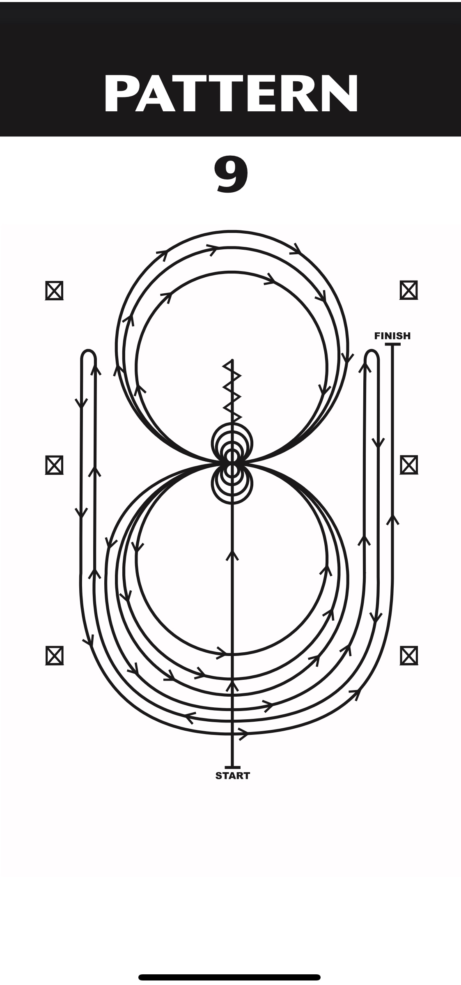
Miss Pattern Instructions
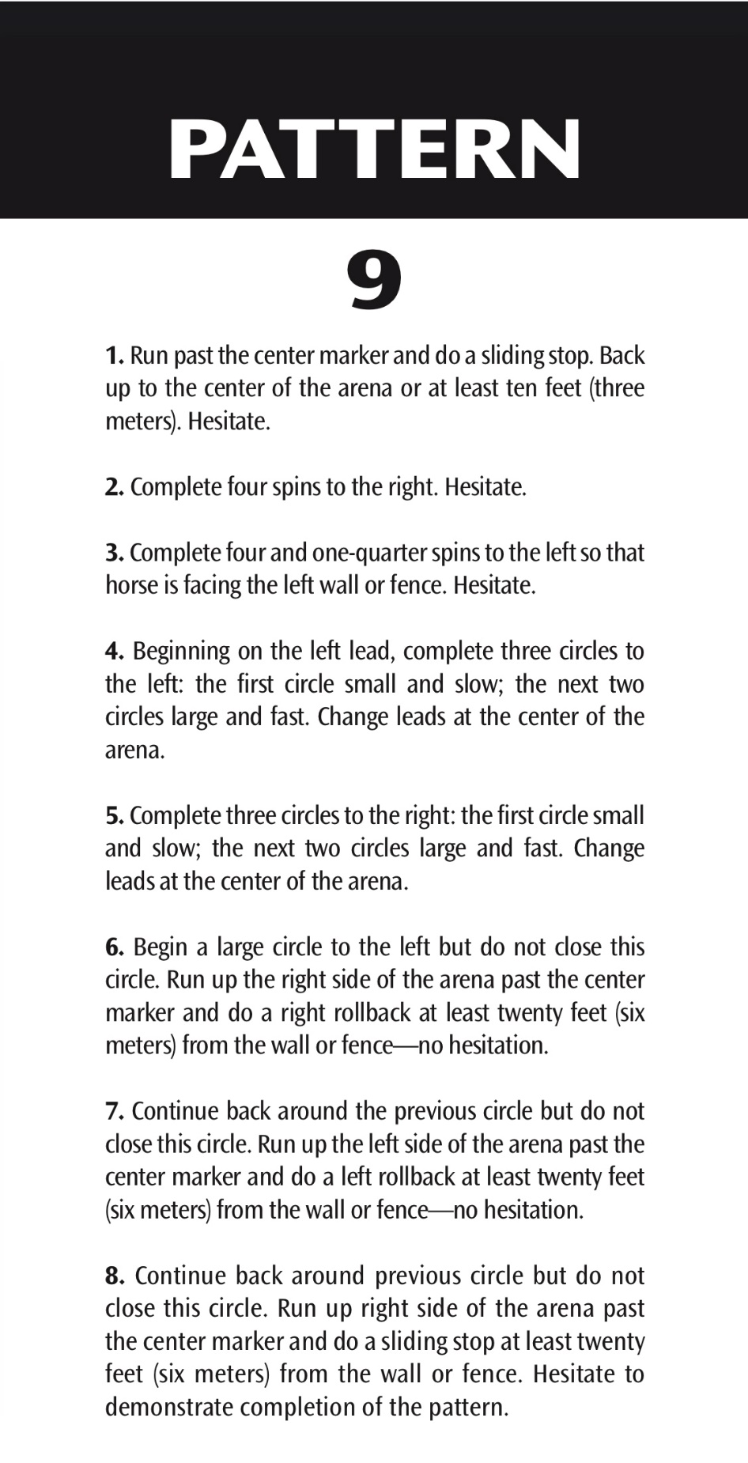
Little Miss Pattern
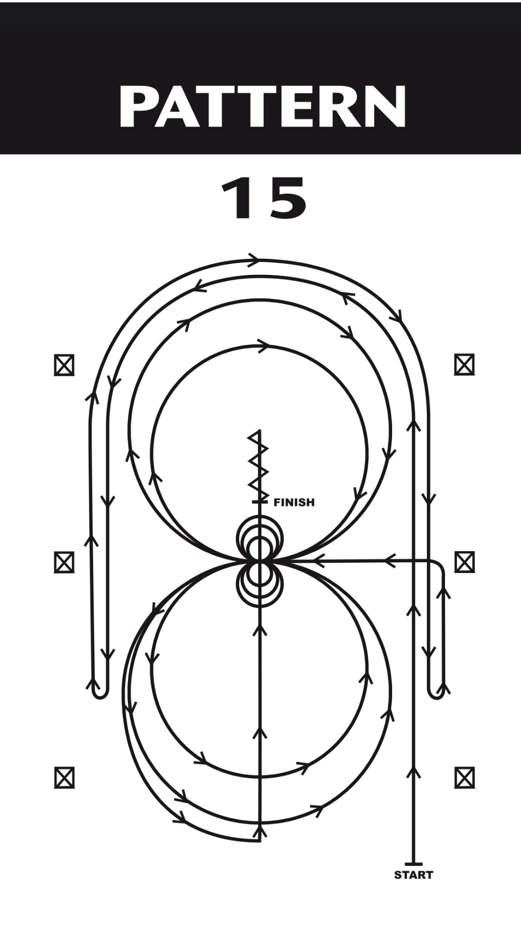
Miss Pattern Instructions
